Safety First : Always decant fuel in an open, well ventilated area using appropriate protective clothing (gloves, eyeglasses). Use only Dangerous Goods approved containers.

Oil / Fuel
Percentage (%) Mixture

Lubricant  percentage | Oil | Fuel
Lubricant  percentage | Oil | 1L | 2L | 3L | 4L | 5L | 10L | 20L | 25L
15% | Oil | 150ml | 300ml | 450ml | 600ml | 750ml | 1.5L | 3L | 3.75L
16% | Oil | 160ml | 320ml | 480ml | 640ml | 800ml | 1.6L | 3.2L | 4L
17% | Oil | 170ml | 340ml | 510ml | 680ml | 850ml | 1.7L | 3.4L | 4.25L
18% | Oil | 180ml | 360ml | 540ml | 720ml | 900ml | 1.8L | 3.6L | 4.5L
19% | Oil | 190ml | 380ml | 570ml | 760ml | 950ml | 1.9L | 3.8L | 4.75L
20% | Oil | 200ml | 400ml | 600ml | 800ml | 1000ml | 2.0L | 4.0L | 5.0L
21% | Oil | 210ml | 420ml | 630ml | 840ml | 1050ml | 2.1L | 4.2L | 5.2L
22% | Oil | 220ml | 440ml | 660ml | 880ml | 1100ml | 2.2L | 4.4L | 5.5L
23% | Oil | 230ml | 460ml | 690ml | 920ml | 1150ml | 2.3L | 4.6L | 5.75L
24% | Oil | 240ml | 480ml | 720ml | 960ml | 1200ml | 2.4L | 4.8L | 6L
25% | Oil | 250ml | 500ml | 750ml | 1000ml | 1250ml | 2.5L | 5L | 6.25L

Note : Pour the amount shown in the light blue area into a container and then top up to amount listed in red colour.

Petrol to Oil
Ratio Mixture

Petrol to oil ratio | Oil | Oil per 1 Lt of petrol | Oil per 5 Lt of petrol | Oil per 10 Lt of petrol | Oil per 20 Lt of petrol
16:1 | Oil | 62.5 ml | 313 ml | 625 ml | 1250 ml
20:1 | Oil | 50 ml | 250 ml | 500 ml | 1000 ml
25:1 | Oil | 40 ml | 200 ml | 400 ml | 800 ml
30:1 | Oil | 33.3 ml | 166 ml | 333 ml | 666 ml
32:1 | Oil | 31.3 ml | 157 ml | 313 ml | 626 ml
35:1 | Oil | 28.6 ml | 143 ml | 286 ml | 572 ml
40:1 | Oil | 25 ml | 125 ml | 250 ml | 500 ml
45:1 | Oil | 22.2 ml | 111 ml | 222 ml | 444 ml
50:1 | Oil | 20 ml | 100 ml | 200 ml | 400 ml
55:1 | Oil | 18.2 ml | 91 ml | 182 ml | 364 ml
60:1 | Oil | 16.7 ml | 84 ml | 167 ml | 334 ml
70:1 | Oil | 14.3 ml | 72 ml | 143 ml | 286 ml
80:1 | Oil | 12.5 ml | 63 ml | 125 ml | 250 ml
90:1 | Oil | 11.1 ml | 56 ml | 111 ml | 222 ml
100:1 | Oil | 10 ml | 50 ml | 100 ml | 200 ml

Note : Pour the amount shown in the light blue area into a container and then top up to amount listed in red colour.

Disclaimer: Aeromodellers New South Wales does not take responsibility for the mixing of fuels or the suitability of mixing ratios for different engines as used or applied by modellers themselves. Each Modeller shall ensure the mix ratios and information in any of the provided charts is correct and suitable for the engine types they are operating in accordance with manufacturers specifications and requirements.

Propeller size chart

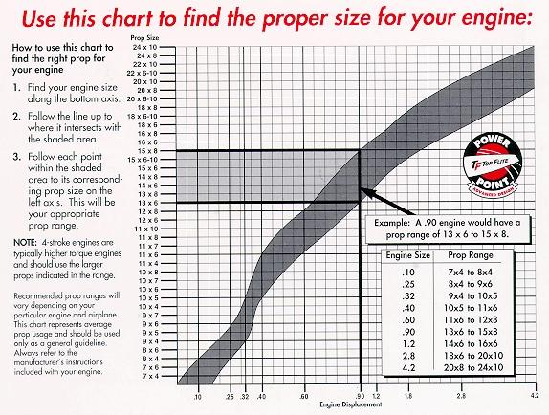

Glow Plugs

No. F – This plug is for all O.S. multi-cylinder and 4-stroke engines. Long reach – long life

No. A5 (New No. 10) – A medium-cold plug ideal for engines .60 and larger

No. 7 – A medium-hot plug suitable for most 2-stroke airplane, helicopter and cars (except turbo heads). Ideal for helicopter hovering, 3D and F3C type flight.

No. 8 – A medium-hot plug suitable for most 2-stroke flight engines. A flyers favourite

No. A3 (New No. 6) – A long-lasting hot plug for most 2-stroke engines up to .60

Glow Plugs Hints

- Remove crud from around pug before you remove the plug.
- New plug, new gasket.
- To prolong glow plug life, remove glow starter promptly after engine start.
- Avoid running the engine to empty.
- Keep your plugs packaged to protect them from damage, dust & grit.
- Don’t over tighten a plug.

