Accommodation
Camping / Caravan
Camping Sites are available at the field,
We have lighting and some mains power derived from our solar system.
Hot shower facility is also available.
Food is served Friday nights as well as breakfast and lunch
Big Roast dinner is available at the field on Saturday nights $30:00 per head including dessert
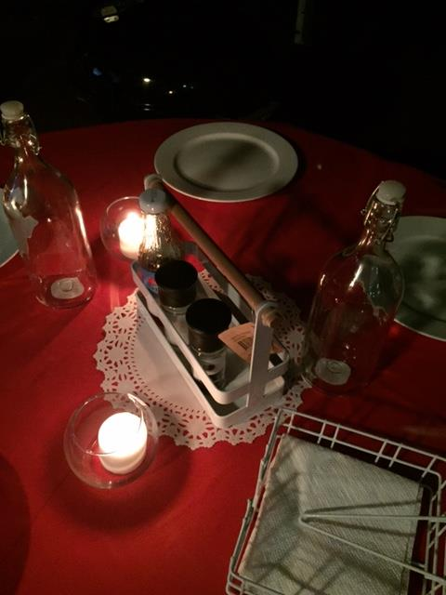

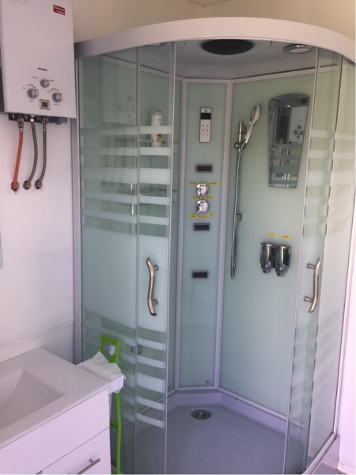

Please email for more information
TheScaleAviators@outlook.com

Or Phone
0416015712
0414286116

Outward Bound accommodation facility
Only 7 km straight down the road towards Canberra from the NAAS field.
It is a large complex and has accommodation meeting rooms and a range of other facilities.
Outward Bound have bunkhouse dorm rooms that sleep 8 people in each.
There are bathrooms and toilets attached to the rooms.
The cost for these rooms is $35 p/person p/night.
Bedding unfortunately is not provided.
Outward Bound also have tent sites at $10 per person. If you would like these I'll just have to double check that sites are available with our operations team.
Less than 10 Mins to the Field.
Contact
Christine Martin
Administration Assistant
Outward Bound Australia
web page: www.outwardbound.org.au
(02) 6235 57|1800 267 999
email: christinem@outwardbound.org.au
Alpha Hotel Tuggeranong
(02)62933666
(about 20kms from field, very nice accomodation .)
http://www.alphahotelcanberra.com.au/tuggeranong/
http://www.alphahotelcanberra.com.au/canberrahotel/about/
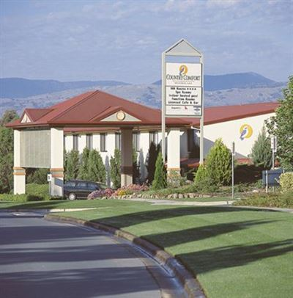

Orroral Camping ground Namadgi National Park
This is very cheap, but very basic, fairly close to the field
http://truecamping.com.au/campsites/ad/orroral-campground-namadgi-national-park-1
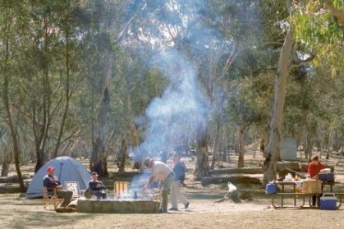
BEST Western Plus Garden city Hotel
55 Jerrabomberra Avenue, Narrabundah ACT 2604
(02) 62953322
30 Mins to field
HOTEL IBIS STYLES
203 Goyder steet Narrabundah ACT 2604
(02) 62952944
30 mins to field
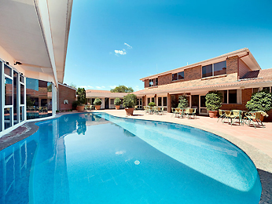

Greenleigh Central Motel
106 Cotter road Curtin 2605
Also has family cabins
(02) 62815881
30 mins to field

